

BASIC MECHANICS
STATS  Strength  Speed  Intellect  Combat | SAVES  Sanity  Fear  Body

`
CHECK  Roll: d100 < Stat/Save + Skill  Failure: +1 Stress  Critical: Roll doubles.  - Critical Success: Something good happens.  - Critical Failure: Something bad + Panic Check  - 00 = Always Critical Success / 99 = Always Critical Failure  Advantage [+]: Roll twice, best result.  Disadvantage [-]: Roll twice, worst result.  STRESS  Default Minimum Stress: 2  Maximum Stress: 20  Relieve Stress: Rest in relatively safe place.  - Rest save using worst Save.  - Success: Reduce Stress by ones digit rolled.  - Failure: +1 Stress  - Rest [+]: Consensual sex, recreational drug use, night of heavy drinking, prayer, other suitable leisure activity.  - Rest [-]: Unsafe locations.  PANIC CHECK  Roll: d20 > Current Stress  Failure: See result on Panic Effects Table (PSG 21).  - Watching crewmember die.  - More than 1 crewmember panics at the same time.  - Encountering strange/horrifying entities for first time.  - When all hope is lost and death feels certain.  - Whenever the player wants. | SKILLS
  TRAINED (+10) |  | EXPERT (+15) |  | MASTER (+20)
   | COMBAT / PHYSICAL
  Athletics  Military Training  Zero-G | Explosives  Firearms  Hand-to-Hand Combat  Piloting |  | Hyperspace
   | TECH / ENGINEERING
  Computers  Industrial Equipment  Jury-Rigging | Asteroid Mining  Hacking  Mechanical Repair |  | Artificial Intelligence  Cybernetics  Engineering
   | MEDICAL
   | Field Medicine  Pathology  Pharmacology  Psychology |  | Surgery  Sophontology
   | ACADEMIC / SCIENCE
  Archaeology  Art  Botany  Chemistry  Geology  Linguistics  Mathematics  Theology  Zoology | Ecology  Mysticism  Physics |  | Exobiology  Planetology  Robotics  Xenoesotericism
   | OTHER
  Rimwise | Wilderness Survival |  | Command
VIOLENT ENCOUNTERS  Round: 10 seconds  Surprise: Fear save  - Failure: Cannot act in 1st round.  Turn  - Action + move within Close Range; or  - Run within Long Range.  Attack: Combat check to inflict damage.  - Weapon Range = Maximum range  - Unarmed Damage: STR/10 DMG  Armor  - Armor Points (AP): Subtract from damage. If DMG ≥ AP, reduce AP by 1. If AP = 0, armor destroyed. If DMG ≥ AP x 2,  - Damage Reduction (DR): Reduces damage before applying/checking AP.  - Anti-Armor (AA): Attack ignores armor. AP -1, and -1 if damage ≥ AP. (Crit = Armor Destroyed)  - Repair: ½ original cost of the armor.  Health = 0: Gain Wound, reset Health to Maximum.  Wound: Roll on Wounds Table (PSG 29).  - Maximum Wounds: Death save (PSG 29).  Death Save: Roll 1d10 in cup and hide it.  - Someone Checks: Reveal and compare roll to Death Table (PSG 29).  Range Bands  - Adjacent (1m): Touching / interacting with. Smell.  - Close (5-10m): Throw object. Smell powerful stench. Talking can be heard across room.  - Long (20-100m): Yell to get attention. Can’t smell.  - Extreme (100m+): Might not be able to locate scream.  Cover: Destroyed like armor.  - Insignificant Cover (wood, body shields): AP 5  - Light Cover (trees, bulkheads, metal): AP 10  - Heavy Cover (airlocks, cement, ships): DR 5, AP 20 |  | THREAT SYSTEM  Round:  - GM makes a Threat (usually Auto Damage + Chaser).  - PCs declare and resolve actions.  - GM resolves Threat and sets a new Threat.  Countering Threat: If the PCs’ actions do not counter the Threat, then the Threat is resolved.  - Countering Threat may or may not require a check.  - If Threat is fully countered, PCs may also be able to gain Edge.  Threat Chasers  - Use Special Ability  - Ravage (Combat check to deal attack damage)  - Multiple Targets  - Trap PC(s)  - Environmental Complication  - Slaughter the Innocent (take out one or more bystanders)  - Escalate (see below)  EDGE  Horror Has Edge: By default, Horror starts with Edge.  - Can make full Threat (Auto Damage + Chaser).  PCs Have Edge: Horror’s Threat is limited to one of the following.  - Combat check to deal damage / use a special ability  - Gain Edge  - Withdraw  Escalation: If you have the Edge, you can escalate your Edge.  - Horror: For each escalation, add an additional chaser to Threat.  - PCs: Gain a benefit or inflict a penalty on the Horror.
  SAMPLE ACTIONS  - Attack  - Bandage a wound  - Check vital signs with medscanner  - Fire vehicle weapon  - Maneuver/pilot a vehicle  - Open airlock  - Operate a machine  - Reload a weapon  - Throw something  - Use a computer terminal (search directory, engage automatic airlocks, send distress signal, cycle through CCTV cameras, disable Life Support, etc.) | FAILED CHECKS — SAMPLE CONSEQUENCES  - Horror inflicts automatic damage.  - Horror makes Combat check to inflict damage.  - Horror gains Edge / PCs lose Edge.  ESCALATION — SAMPLE PC BENEFITS  - Withdraw.  - Isolate the Horror.  - Force the Horror to make its checks with disadvantage.

SURVIVAL
ATMOSPHERES  Toxic Atmosphere: Not fit to breathe, but otherwise safe.  - Requires rebreather/oxygen supply, or 1d10 DMG per round, Body save ½.  Corrosive Atmosphere (range)  - Mildly Corrosive: 1 DMG/round  - Highly Corrosive: 10 DMG/round  BLEEDING  Bleeding: 1 DMG/round until bleeding stopped.  - Cumulative (e.g., Bleeding 1 + Bleeding 2 is 3 DMG/round).  - Ignores AP/DR.  CARRYING CAPACITY  - Average person = ¼ body weight  - Average marine = 90-160 lbs. in combat  - Androids = 1-5x that amount  - Carry one light thing in each hand or one heavy thing in both hands.  CRYOSICKNESS  Cryosick: [-] all checks for 1 week after waking from cryosleep.  - Stimpack: Immediately ends cryosickness.  - Upgraded Cryopods: Can mitigate effects.  DRUNKENESS  Drinking: Body Save. On failure, [-] to all rolls for 1d10 hours.  - [+] after a few drinks. [-] for long night of heavy drinking.  EXHAUSTION  Exhaustion: After 12 hours, Body save every hour.  - Failure: 1 DMG  - 24 Hours: [-] on all rolls until rest for 8 hours. | FOOD & WATER  Vacuum: 15 seconds without oxygen, then unconscious for 1d5 minutes before dying.  Life Support Offline  - 1d10 x maximum crew capacity = oxygen supply in days per person.  - Oxygen < Passengers x 2: [-] on all rolls (headaches, fatigue, anxiety, clumsiness)  - Oxygen < Passengers: Body save or make Death save (panting, dizziness, severe headaches, impaired vision, tinnitus).  - No Oxygen: Per vacuum.  - Cryosleep: Do not consume oxygen.  - Strenuous Activity: +2 oxygen per person  Androids: Do not require oxygen.  RADIATION  Radiation Shielding: Blocks all radiation levels.  Radiation Pills: 1d5 DMG, -1 Radiation Level for 2d10 minutes.  TEMPERATURE  Extreme Cold: 1/hour — Body save or Death save  - Hypothermia / Frostbite: sub-zero temperatures  Extreme Heat: 1/hour — Body save or Death save  - Heat Stroke: over 100°F/40°C
  LEVEL | DAMAGE
  LEVEL 1 – TRACE  Normal, everyday radiation. Cosmic rays. | None immediately.  Possible long-term effects (cancer, etc.)
  LEVEL 2 – ACUTE  Unshielded reactors / warp cores. | All Stats/Saves -1 per round.
  LEVEL 3 – LETHAL  Atomic weapons, handling warp cores. | 1/round: Body save or lethal dose (death in 1d5 days).

PORTS  PORT CLASSES  (PSG 38)  X-Class: criminal settlements, pirate bases  C-Class: rundown, out-of-the-way, refueling stations, forward military posts  B-Class: industrial stations, large-scale military installations  A-Class: metropolises, trading centers, power brokers  S-Class: pleasure spas, palatial estates, heavily guarded, invite only  SHORE LEAVE  Cost: As indicated by type of port.  Length: approx. 2d10 days  - Shortened Shore Leave: Penalties at Warden’s discretion.  Shore Leave: Sanity save  - Success: Convert Stress to Improved Saves, reset to Minimum Stress.  - Critical Success: Convert maximum Stress allowed by Port.  - Failure: Reset to Minimum Stress, then +1 Stress for failing check.  - Critical Failure: Do not convert or relieve any stress. Make Panic check.  Convert Stress: +1 to any Save per 1 converted Stress  SHORE LEAVE COSTS | MEDICAL CARE  First Aid Kit: Stops Bleeding. Can stabilize patient and treat Minor Injuries.  - Improvised Bandages: Intellect check. [-] if not trained in Field Medicine. On success, remove Minor Injury Wound. On failure, stabilize condition, but both treater and patient suffer 1 Stress.  Field Surgery: 1d10 hours. Make Intellect check, [-] if not trained in Surgery. On success, remove Major Injury Wound. On failure, patient suffers 1d10 DMG.  Stimpak: -1 Stress, +1d10 Health, [+] on all rolls for 1d10 minutes.  - Overdose: Roll 1d10. If < # of doses in past 24 hours, make Death Save.  Short-Term Recovery: 6+ hours of rest = Body save  - Success: Reset Health to maximum.  Comatose: Comatose character must have a Wound treated to wake up.  MEDICAL TREATMENTS  (can remove Wounds and/or Conditions)
  PORT | COST | STRESS CONVERTED
  X-Class | 1d100 x 10 kcr | 2d10[+]
  C-Class | 2d10 x 100 cr | 1d5
  B-Class | 2d10 x 1 kcr | 1d10
  A-Class | 2d10 x 10 kcr | 2d10
  S-Class | 2d10 x 100 kcr | All
  TREATMENT | COST | DESCRIPTION
  Artificial Wellness Counselor | 150cr | 1 hour session (max. 1/week). Restores 1 Sanity save. 1% gain random Condition (PSG 21).
  Cognitive Defragmentation | 100kcr | 24 hour surgery. Removes 1 Condition. 1% chance of total amnesia. [-] on Intellect, Sanity, Fear for 4 weeks.
  Deep Tissue Nanogel Massage | 24kcr | 1 hour session (max. 1/week). -1 Minimum Stress. [-] on all actions for 24 hours.
  Immersive Slicksim Therapy | 1kcr | 4 hour VR. Restores 1d10 Combat or 1d10 Fear Save. 1% chance stuck in immersion for 1d10 days and lose 1d5 Sanity Save.
  Medpod | 6kcr | 1 week pod treatment. Restore 1 Wound. (Does not restore lost limbs/digits.)
  Pseudoflesh Injection | 18kcr | 8 hour surgery. Restores 2d10 Speed, 2d10 Strength, 2d10 Body Save, or all Wounds. [-] all rolls for 2 weeks + 4 weeks convalescent recovery required.
  Psychosurgery | 28kcr | 8 hour surgery. Restores Intellect, Sanity, or Fear to maximum. Or reduce Minimum Stress to 2. [-] all rolls for 4 weeks.

SHIP STATS  Thrusters  Battle  Systems  Ship Checks:  - Crew Skills: 1 crew member may add skill bonus to a ship check.  - Failure: All crew suffer 1 Stress.  - Critical Failure: All crew make Panic Check.  SPACE TRAVEL  Launching & Landing: Most ships rely on shuttles to land on planet.  Interplanetary Travel  - Inner System: Days  - Outer System: Weeks  Fuel  - Interplanetary: 1 fuel per month  - Jump: 1 warp core per jump  JUMPS  Jump Points: Rated Jump-1 to Jump-9.  - Require a jump drive of equal or higher rating.  - Usually located in Outer System.  Jump Length: 2d10 days, subjective  - Time Dilation: Roll 1d10 per Jump rating. For each 1, actual trip duration increases by one step (days to weeks, weeks to months, months to years, years to decades, decades to centuries).  Cryosleep: Staying awake during jump = strange, conflicting experiences.  - Androids experience less disorientation; often left to monitor the astronavigation computer. | SPACE – DETECTION & RANGE  RANGE & DISTANCE  SHIP COMMUNICATION  Transponder: Automated system that transmits callsign, captain’s name, ship type, class, home port, destination, etc.  DISTRESS SIGNALS  Outer System: +1 step  Isolated System: +1 die roll
  CLASS | DESCRIPTION | EXAMPLES
  0 | Shuttlecraft | Shuttle, Fighter, Dropship
  I | Light Commercial | Raider, Executive Transport
  II | Medium Commercial | Freighter, Patrol Class
  III | Heavy Commercial | Salvage Cutter, Jumpliner
  IV | Light Military | Corvette
  V | Medium Military | Exploration Vessel, Troopship
  RANGE | DISTANCE | TIME | SENSORS / SCANNERS | WEAPONS
  Detection | Same star system | Weeks | trajectory, rough size, transponder | Railgun
  Firing | Planet to moon | Days | ship class, type | All Weapons
  Contact | Planet to close orbit | Minutes | presence of lifeforms, ship status | Boarding
  RANGE | LATENCY
  Contact | None
  Firing | Seconds
  Detection | Minutes to Hours
  Beyond | Hours to Days (if ever)
  D10 | RESPONSE TIME | EFFECT
  00 | 2D10 Days
  01-02 | 2D10 Weeks
  03-04 | 2D10 Months
  05-06 | 2D10 Years | Body Save or -1d5 all Stats/Saves.
  07 | 2D10 Decades | Body Save [-] or -1d10 all Stats/Saves.
  08-09 | NEVER | Thanks for playing Mothership.
SHIP REPAIRS  Maintenance Issues Table (SBT 39)  Starting Condition: When acquiring ship, roll 1d5+1 Repairs.  Routine Maintenance (1/year): Systems Check  - Dedicated Engineer: [+] on check  - Failure: Roll for Repair  - Critical Failure: Roll twice for Repairs  Minor Repairs: 2d10 days  - May require stat check if lacking tools, time, etc. If so, critical failure escalates the problem to a Major Repair.  Major Repairs: Includes MDMG and Hull.  - Requires port.  - Costs 1d5 mcr x ship’s class.  - Completing all major repairs requires months or years.  REFUEL & RESUPPLY  Siphoning Fuel:  - Same Class: Siphon on 1:1 basis.  - 1 Class Below: Siphon 2:1 basis.  - 1 Class Above: Siphon 1:2 basis.  - All other fuel incompatible.  Resupplying Weapons: Must resupply after each ship combat.  - No Resupply: [-] Battle Checks next ship combat. If still no resupply, auto fail Battle Checks.  Refuel/Resupply Costs: SBT 30 |  | CONTRACTORS  (Random Contractors – PSG 41)  CONTRACTOR STATS  Combat: As per PCs.  Instinct: Rolled for all other checks (Fear, Sanity, Body, Speed, Intellect).  Max Wounds: Any damage taken = 1 wound.  Loyalty Save: Rolled to make decision between what’s best for them and what’s best for employer.  - Starting Loyalty: 2d10+10  - Improving Loyalty: +1 for paid, successful job (+1d5 or +1d10 for exceptional circumstances)  Motivation: If any, always fail Loyalty Saves when the two come in conflict.  HIRING CONTRACTORS  Salary: 1/month  Hazard Pay: 1d5 months extra pay  - Non-Payment / Partial Payment: Loyalty Save [-]  Beneficiary: Will seek payments owed in case of death.  Loadout: Basic tools/weapon for their job. Roll Loadout.

SHIP-TO-SHIP COMBAT
Ship Rounds: Minutes (contact) or Hours/Days (firing)

1. MOVEMENT PHASE  Secret Choice: Maintain Course, Evade, Pursue  Maintain Course: Spend no extra fuel. Opponent automatically succeeds at Evade or Pursuit.  Evade: Spend any amount of Fuel ≥ Evasion Minimum.  Pursue: Spend any amount of Fuel.  Resolve Movement: Thrusters check.  - Most Fuel spent = [+] on Thrusters check.  - Success vs. Failure: Increase or Decrease range band by 1.  - Critical Success: Increase or Decrease range band even if enemy succeeded.  - Critical Failure: Enemy increases or decreases range band even if they failed.  - Tie: No change. | 2. ATTACK PHASE  Attack: All ships within Firing range choose target and make Battle Check.  - Critical Failure: Suffer +2 MDMG.  - Failure: Suffer +1 MDMG.  - Success: Deal MDMG to target.  - Critical Success: Deal MDMG x 2 to target.  Unarmed Vessel: Automatically fail Battle Checks.  Hull: Subtract from damage. If damage ≥ Hull, then Hull -1 after hit.  Megadamage (MDMG): Add MDMG to total, then apply listed effect.  Unwinnable Fights:  - vs. Class -1: [+] on all Batlte Checks  - vs. Class +2: Unbeatable in direct confrontation.  3. MORALE PHASE  Morale Check: If enemy ship suffered MDMG, roll 1d10.  - < MDMG: May send hail offering ceasefire/resume negotiations.
  RANGE | MINIMUM EVASION FUEL
  Contact | 3 Fuel
  Firing | 2 Fuel
  Detection | 1 Fuel
  MDMG | EFFECT
  01 | Emergency Fuel Leak. Every time you spend Fuel, spend +1 Fuel.
  02 | Weapons Offline. Auto fail Battle Checks.
  03 | Navigation Offline. Cannot make Thruster checks. 10% all navigational data wiped.
  04 | Fire on Deck. Toxic + Highly Corrosive Atmosphere for locations on fire.
  05 | Hull Breach. All aboard make Body save or take 1 Wound (Explosion). On critical failure, get sucked into space.
  06 | Life Support Offline. Oxygen limited to 1d10 x maximum crew capacity.
  07 | Radiation Leak. Radiation Level +1 every 2d10 minutes.
  08 | Dead in the Water. All systems offline. Emergency power only.
  09+ | Abandon Ship! Ship is destroyed in 1d10 minutes.

AFTER BATTLE REPORT
After Battle: If ship suffered MDMG, make a Systems Check.
- Failure: Roll on Maintainence Issues Table (SBT 39).
- Critical Failure: Roll twice.

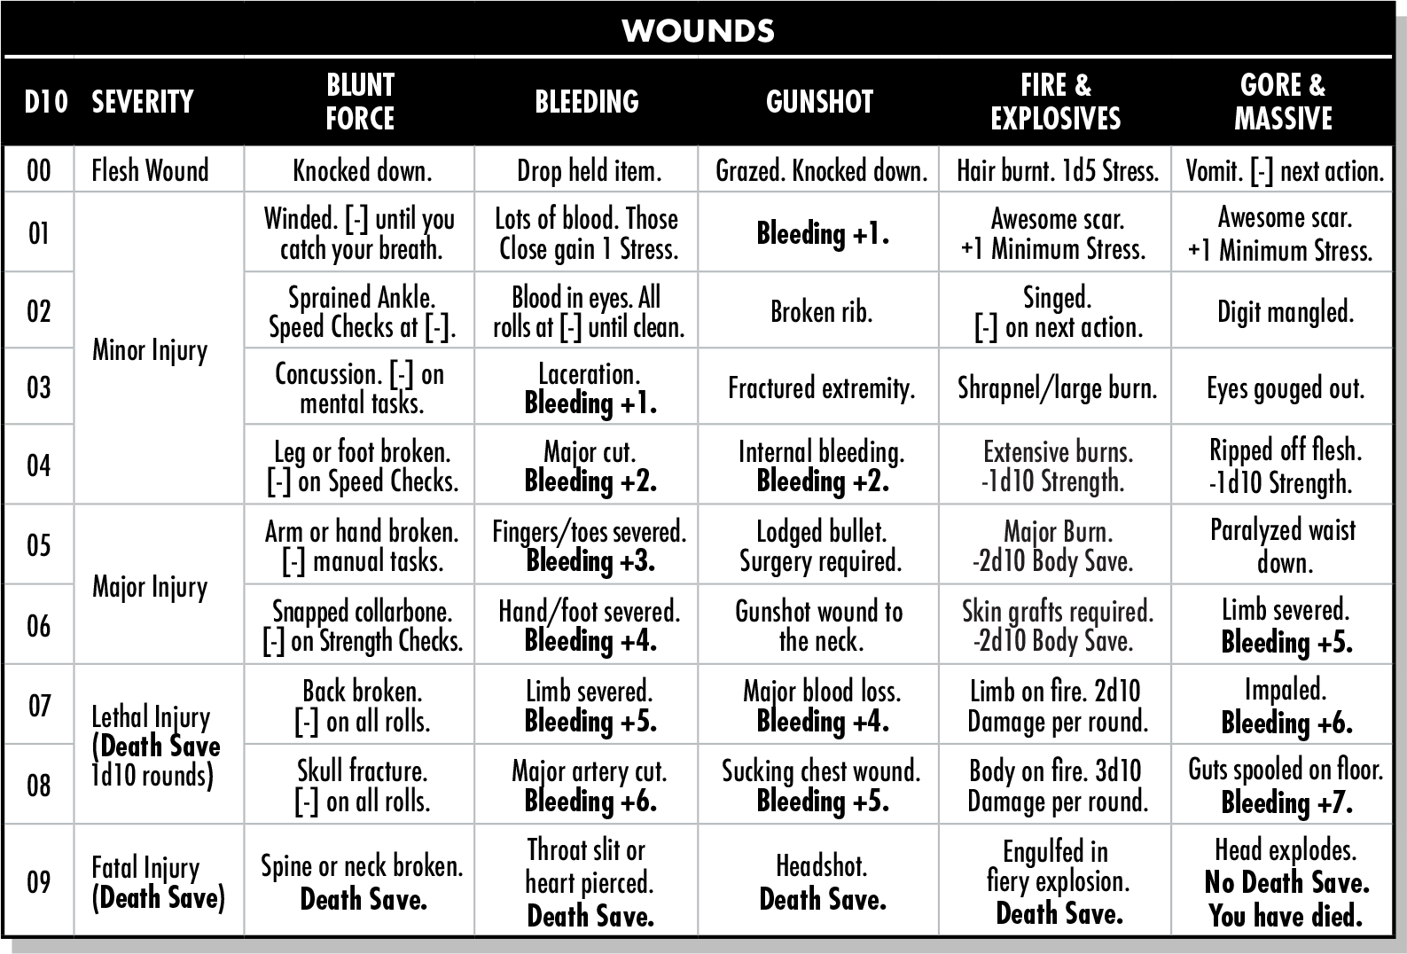 | 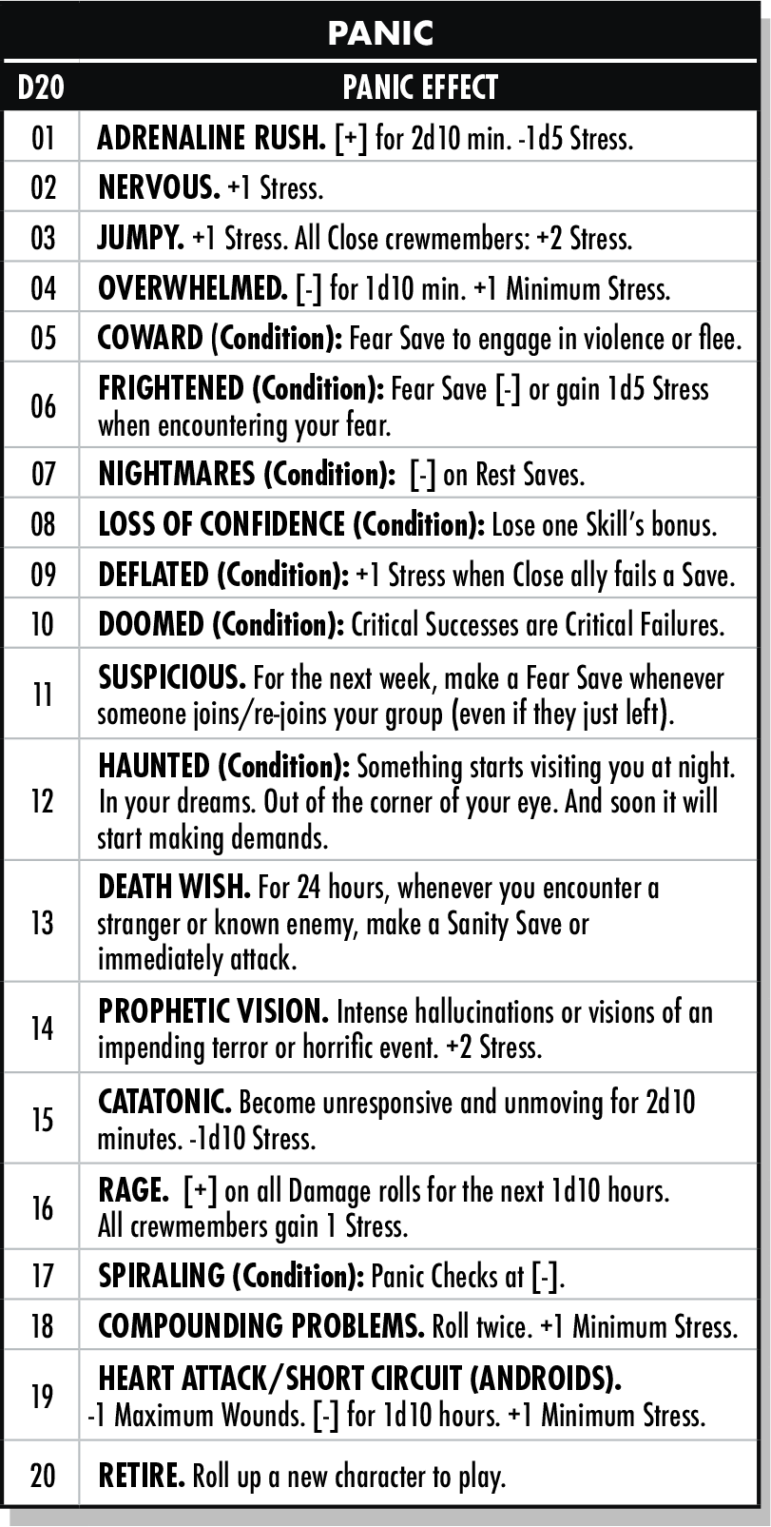
  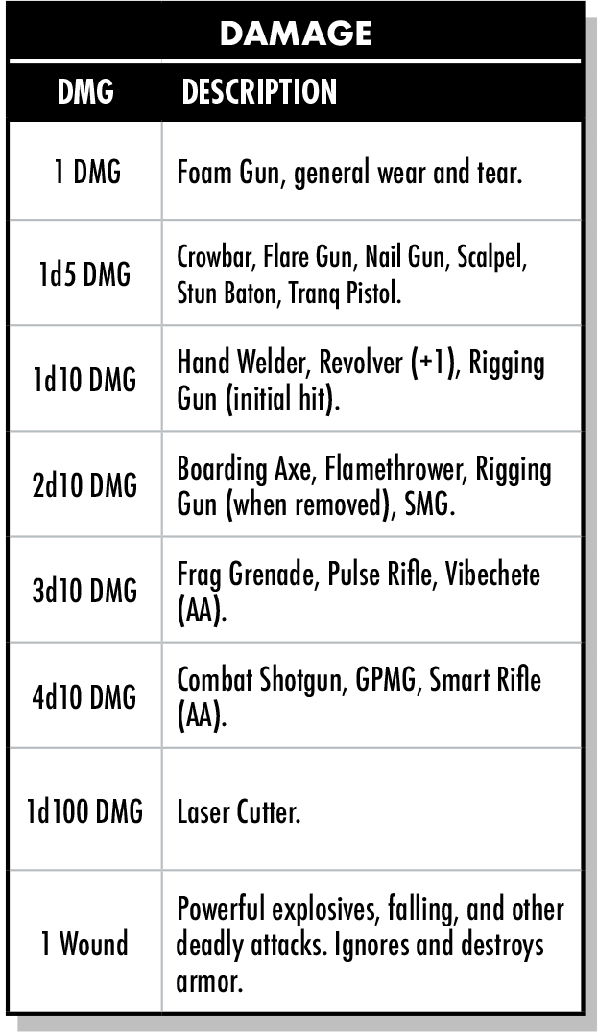 | 